OS LAB – 4

PROGRAM FOR RATE MONOTONIC SCHEDULING:
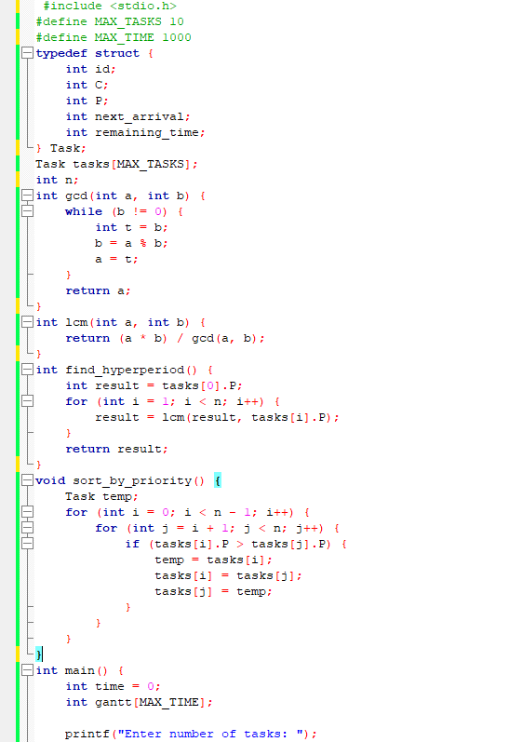
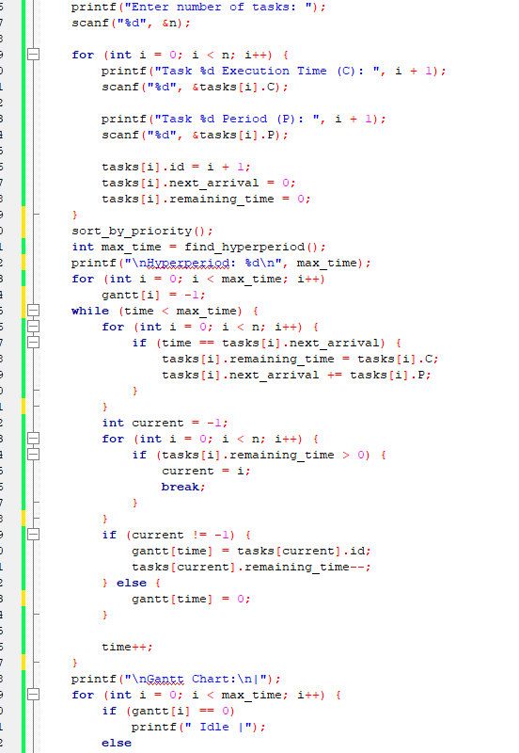

OUTPUT:
